**One Health, Green Cities, and Well-being**

Authored by Charles Yang

Ever since we learned that COVID-19 first came from bats, people have become obsessed with zoonoses, whether they know the term or not. This pandemic is most likely a zoonosis, jumping from bat to human in an open-air market in Wuhan, China (Bhargava et al., 2021). However, coronaviruses have been endemic in bats for a very long time (Wildlife Society, 2020). This fact poses a few questions about the pandemic: Why now and how? The One Health (OH) paradigm attempts to answer these questions from a multidisciplinary approach. By looking at the environmental, ecological, human, and animal conditions in which pathogens thrive and spread, we can better predict and control pandemics before they ever occur. In MICRO 265X, I learned through several concrete case studies of outbreaks that demonstrate how the world around us is connected to our individual and communal health. More importantly, however, OH teaches us that we can find solutions to these problems by carefully studying pathogens in our shared world.

During the pandemic, the mental health of millions of Americans suffered. In the first half of 2019, approximately 11% of adults reported having some anxiety or depressive disorder. In just January 2021, we saw that figure rise to a staggering 41.1% (Panchal et al., 2021). The pandemic hit urban areas harder, causing significantly worse mental health outcomes in China (Czeisler et al., 2020). During these times, going outside is an excellent activity for those trying to escape the monotony of home. From an OH standpoint, improving our urban green spaces could be a step toward better mental wellbeing. If we want to justify any extended restrictions in cities, whether in the past or the present, we must take steps to protect mental health.

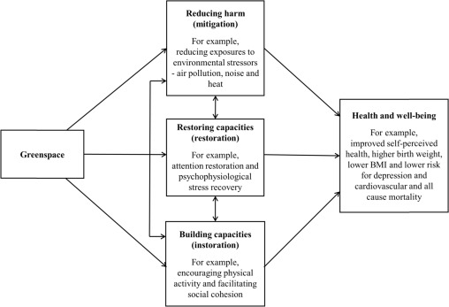Green spaces can often promote additional walking for city residents. Since walking is associated with human health, both physical and mental, we can see an “implicit link” between green spaces and public wellbeing (Zhang et al., 2020). Another paper breaks down the benefits of urban green space into three categories that do not just involve walking: reducing harm, restoring capacities, and building capacities.

*Linking greenspaces and human wellbeing* (Markevych et al., 2017)

However, note that there are potential cons that come with green spaces, including but not limited to increased allergies, habitats for animals that could cause zoonoses, exposure to gardening chemicals, and feelings of unsafety (Markevych et al., 2017). Because of these, it can be hard to improve to quality of greenspaces with more diverse fauna and wildlife. The question then becomes: how can we design urban infrastructure to minimize the cons and maximize the pros? A systematic review of green infrastructure literature tried to find the best way to promote mental health in cities with greenspaces and still support wildlife, leading to several key findings (Felappi et al., 2020). It found that plant diversity and complex vegetation structures are associated with better wildlife support. City habitats that utilized native vegetation were positive affecting avian and lepidopteran animals. Areas with more building cover and concrete surfaces worsened wildlife support, but natural tree cover positively affects wildlife. Strangely enough, they observed that parks with more diverse plant life negatively impacted psychological wellbeing. These are just a 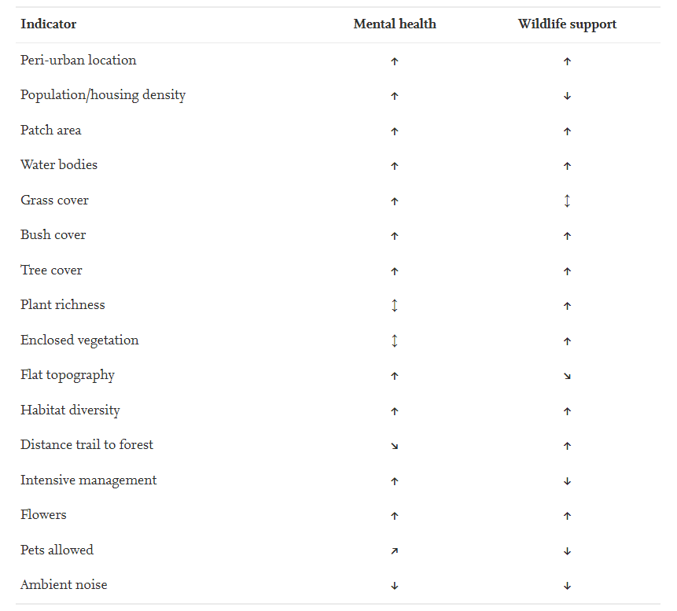few findings found in the study, which the following table summarizes.

*Associations between green indicators, mental health, and wildlife support*

(Felappi et al., 2020)

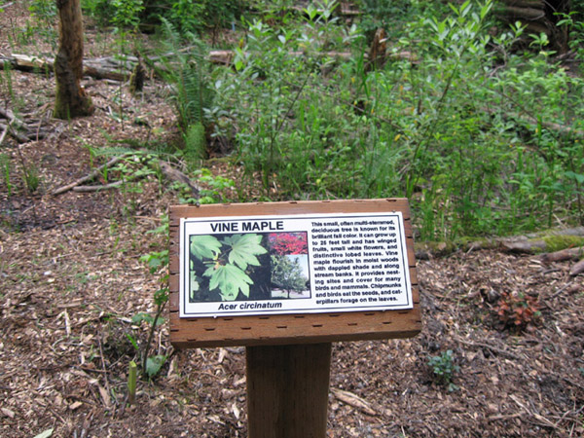Seeking to combat opposite relationships between mental health and wildlife support is a worthy OH goal. One counter-intuitive find from the previous paragraph was the negative correlation between actual plant diversity and mental health. However, the review’s authors argue that due to a lack of public ability to distinguish between species. Perceptions of biodiversity positively correlated with mental health, but not with actual diversity (Felappi et al., 2020). I hypothesize that giving the public the impression of plant diversity will solve this issue. I propose an experiment to try and test this. First, pick a few cities that have green spaces with a high level of plant diversity. We will only work with parks that do not have pronounced signs or material explaining different plant species. Randomly select half the parks to install large, podium-like signs, like that of Figure 1. We will attempt to erect a sign for at least half of the plants in the park. Before installation, we send a survey that collects residents’ mental wellbeing, plant species knowledge, and park usage data. Then, six months after installation, we send out an identical survey. Comparing data between signed and unsigned green spaces after controlling for green indicators for each park, region, and other factors will hopefully provide insight into the effect of these new signs.

Figure 1:

from http://www.kirklandhighlands.org/PlantIDsignInstall/

This experiment is a small step toward achieving a One Health infrastructure that includes green infrastructure. If residents feel better with signed parks, we could design parks to have these signs. We could simultaneously boost human psychological wellbeing and keep a more diverse range of plants in our city parks. Although the scope of inference will be limited, conclusions drawn can still be practical for public policy. In the wake of a newly passed infrastructure bill, cities can tap into new federal infrastructure funds (Albright, 2021). We should focus our spending on improvements on maximizing both human, ecological, and environmental wellbeing. This optimization is the win-win condition that OH seeks. Human health often seems to contradict the health of the creatures and plants that surround us. We too commonly reach for pesticides, herbicides, and herd culling to win an us-or-them game. Perhaps we can conduct further research in our cities and find ways to co-exist, promoting One Health in one world.

**Works Cited**

Albright, A. (2021, November 4). *Ailing U.S. Roads Would Get Relief in Bill Unleashing Federal Aid*. Bloomberg.com. Retrieved November 15, 2021, from <https://www.bloomberg.com/news/articles/2021-11-04/house-bill-lets-cities-tap-federal-aid-for-infrastructure>.

Bhargava, H. D. (Ed.). (2021, August 15). *Coronavirus history: How did coronavirus start?* WebMD. Retrieved November 12, 2021, from <https://www.webmd.com/lung/coronavirus-history>.

*Closely related COVID-19 viruses have long been in bats*. The Wildlife Society. (2020, September 1). Retrieved November 12, 2021, from <https://wildlife.org/closely-related-covid-19-viruses-have-long-been-in-bats/>.

Felappi, J. F., Sommer, J. H., Falkenberg, T., Terlau, W., & Kötter, T. (2020, August 10). *Green infrastructure through the lens of "one health": A systematic review and integrative framework uncovering Synergies and trade-offs between mental health and wildlife support in cities*. Science of The Total Environment. Retrieved November 15, 2021, from [https://www.sciencedirect.com/science/article/pii/S0048969720351184#bb0385le/pii/S0048969720351184#bb0385](https://www.sciencedirect.com/science/article/pii/S0048969720351184%23bb0385le/pii/S0048969720351184%23bb0385).

Czeisler, M., Lane, R., Petrosky, E., Wiley, J., Christensen, A., Njai, R., Weaver, M., Robbins, R., Facer-Childs, E., Barger, L., Czeisler, C., Howard, M., & Rajaratnam, S. (2020, August 14). *Mental health, substance use, and suicidal ideation during the COVID-19 pandemic - United States, June 24-30, 2020*. PMC. Retrieved November 15, 2021, from <https://www.ncbi.nlm.nih.gov/pmc/articles/PMC7440121/>.

Markevych, I., Schoierer, J., Hartig, T., Chudnovsky, A., Hystad, P., Dzhambov, A. M., Vries, S. de, Triguero-Mas, M., Brauer, M., Nieuwenhuijsen, M., Lupp, G., Richardson, E., Astell-Burt, T., Dimitrova, D., Feng, X., Sadeh, M., Standl, M., Heinrich, J., & Fuertes, E. (2017, June 30). *Exploring pathways linking greenspace to health: Theoretical and methodological guidance*. Environmental Research. Retrieved November 15, 2021, from <https://www.sciencedirect.com/science/article/pii/S0013935117303067>.

Melbourne, S., Zhang, X., Sarkar,, C., Chiaradia, A., & Webster, C. (2020, February 13). *Effects of green space on walking: Does size, shape and density matter?* SAGE Journals. Retrieved November 15, 2021, from <https://journals.sagepub.com/doi/10.1177/0042098020902739>.

Panchal, N., Kamal, R., Cox, C., & Garfield, R. (2021, July 20). *The implications of COVID-19 for mental health and substance use*. KFF. Retrieved November 15, 2021, from <https://www.kff.org/coronavirus-covid-19/issue-brief/the-implications-of-covid-19-for-mental-health-and-substance-use/>.